REST Assured

1. REST assured is an API but SOAP UI is a tool.
2. Different implementations and custom logics to be written.
3. Java IDE: IntelliJ IDEA
4. Dowloaded IntelliJ from the following link: <https://www.jetbrains.com/idea/>
5. Unzipped the folder on ~/Documents.
6. Followed the “Install-Linux-tar.txt”
7. Follow Tutorial: https://youtu.be/INylNqN2w_o
8. Request Parameters:
   1. Query paramter
   2. Path parameter
   3. Form parameter

In GET request, 1 and 2 are included. In POST request, 3 is included.

1. Response:
   1. with groovy
   2. with java object
   3. with java path

Project Structure

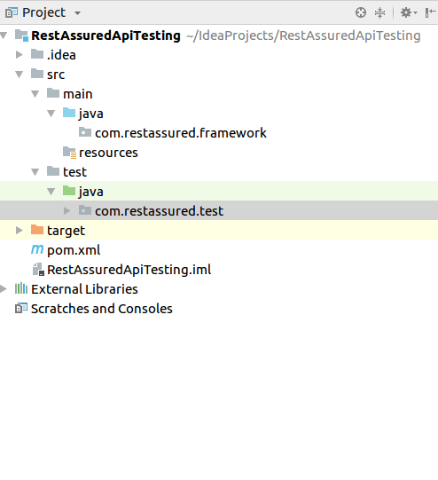

Code to test api testing: Url: “[https://google.com](https://google.com/)”

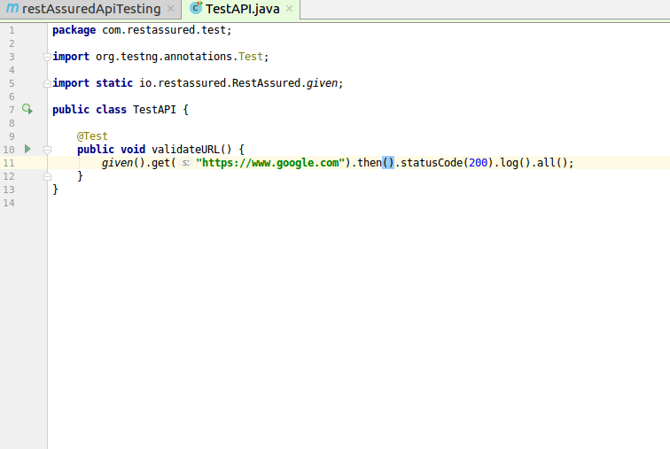

Result / Response from the GET call

